EVEN SEMESTER-2022

RFID attendance system using Microcontroller

MTE PROJECT

## Computer Organization and Architecture

**BACHELOR OF TECHNOLOGY IN**

## COMPUTER ENGINEERING

Submitted by: -

## Shivam Garg (2K20/CO/429) Shaurya Wadehra (2K20/CO/424)

Under the supervision of

## Dr. Ashish Girdhar



**DEPARTMENT OF COMPUTER ENGINEERING DELHI TECHNOLOGICAL UNIVERSITY**

(Formerly Delhi College of Engineering) Bawana road, Delhi-110042

## DEPARTMENT OF COMPUTER ENGINEERING DELHI TECHNOLOGICAL UNIVERSITY

(Formerly Delhi College of Engineering) Bawana road, Delhi-110042

## ACKNOWLEDGEMENT

“Projects not only help a student to learn but to grow as well”.

I would like to express Our thanks and gratitude to the faculty at Delhi Technological University for providing us with the opportunity to work on projects and in the process learn new technologies and learn practical use of our skills. I express Our sincere thanks to our honorable professor **Dr. Ashish Girdhar**, subject **Computer Organization and Architecture**, Delhi Technological University for his constant guidance and support.

I would like to express Our thanks to everyone who guided us through this project and help us complete it successfully.

## DEPARTMENT OF COMPUTER ENGINEERING DELHI TECHNOLOGICAL UNIVERSITY

(Formerly Delhi College of Engineering) Bawana road, Delhi-110042

# ABSTRACT

Nowadays, attendance in schools and colleges is based on paper. Sometimes this process causes errors and takes more time. RFID in this case is definitely a better option. RFID tag is applied to products, individuals or animals to identify and track them. The identification is done through a unique serial number. Therefore, we are making a project that uses RFID technology to make the process of taking attendance efficient and accurate using a microcontroller.

We will be looking in detail the structure of microcontroller 8051. We will be understanding how it functions and in detail about its pins. We will be simulating the circuit of the RFID system on proteus using the same. Along with microcontroller, we will be using LCD and virtual terminal as well. A crystal will also be used to generate frequency. Moreover, we will be building a C code which will be used by the microcontroller to function. In our project, the RFID tag will be matched with the database and in case it founds a user, it marks his attendance else display “No user found” on the LCD.

In the end, we will be looking over the future scope of the same about the various fields it can be used and how the circuit can be improved so as to overcome one of its major drawbacks.

# Introduction

Nowadays, attendance in schools and colleges is based on paper. Sometimes this process causes errors and takes more time. RFID in this case is definitely a better option.

An RFID (Radio-frequency identification and detection) reader is a device which is used to communicate with RFID tags by receiving and transmitting signals. These signals use radio waves for wireless communication. RFID tag is applied to products, individuals or animals to identify and track them. The identification is done through a unique serial number. Therefore, we are making a project that uses RFID technology to make the process of taking attendance efficient and accurate using a microcontroller.

Our particular project would be taking serial input from a virtual terminal, process it through the 8051 microcontroller and display the result on the LCD display.

# Technologies used

We have built the RFID system on Keil μVision and Proteus. Our project involves the 8051 microcontrollers, a virtual terminal, an LCD display and the underlying concepts of serial communication in microcontrollers.

* **8051 Microcontroller**
* A microcontroller is a compact integrated circuit designed to govern a specific operation in an embedded system. It does this by interpreting data it receives from its I/O peripherals using its central processor.
* The temporary information that the microcontroller receives is stored in its data memory, where the processor analyses it and uses its I/O peripherals to communicate and enact the appropriate action. The 8051 microcontroller is one kind of integrated circuit that includes 40-pins with dual inline package, RAM-128 bytes, ROM-4kb & 16-bit timers–2.
* These 40 pins serve different functions like read, write, I/O operations, Interrupts etc.
* **Working of individual pins**
* **Pin 1 to Pin 8 (Port 1)** –Pin 1 to Pin 8 is assigned to Port 1 for simple I/O operations.
* **Pin 9 (RST) –**Reset pin. It is an active-high, input pin. Therefore, if the RST pin is high for a minimum of 2 machine cycles, the microcontroller will reset
* **Pin 10 to Pin 17 (Port 3) –**Pin 10 to pin 17 are port 3 pins. These pins are similar to port 1 and can be used as universal input or output pins. These are being used with the virtual terminal in our project.
* **Pin 18 and Pin 19 (XTAL2 And XTAL1) –**These pins are connected to an external oscillator which is generally a quartz crystal oscillator. They are used to provide an external clock frequency of 4MHz to 30MHz.
* **Pin 20 (GND) –**This pin is connected to the ground. It has to be provided with 0V power supply.
* **Pin 21 to Pin 28 (Port 2) –**Pin 21 to pin 28 are port 2 pins. When additional external memory is interfaced with the 8051 microcontroller, pins of port 2 act as higher-order address bytes. These pins are being used with the LCD display in our project.

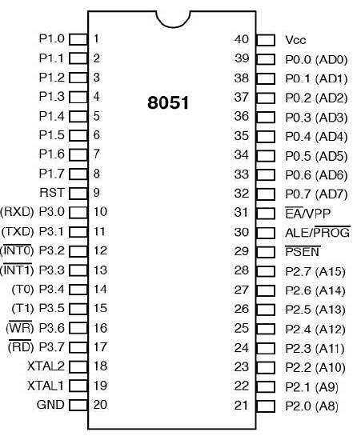

The Microcontroller 8051 involves the following registers: -

* **SCON** (Serial Port Control Register)

The Serial Control or SCON SFR is used to control the 8051 Microcontroller’s Serial Port. Using SCON, you can control the Operation Modes of the Serial Port, Baud Rate of the Serial Port and Send or Receive Data using Serial Port.

* **SBUF** (Serial Buffer Register)

SBUF is an 8-bit register used for serial communication specific programs. For a byte to be transferred via TxD line, it must be placed in the SBUF register. Similarly, SBUF holds the byte of data when it is received by 8051's receive line.

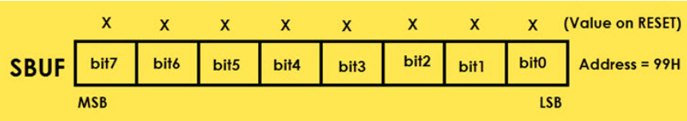

#### **TMOD** (Timer Mode)

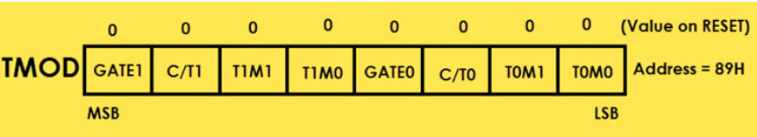The TMOD or Timer Mode register or SFR is used to set the Operating Modes of the Timers T0 and T1. The lower four bits are used to configure Timer0 and the higher four bits are used to configure Timer1.

* **Serial communication**
* Microcontrollers need to communicate with external devices such as sensors, computers and so on to collect data for processing. Data communication is generally done by means of two methods – Parallel and Serial mode. In parallel mode data bits are transferred faster using more data pins. But when comes to a Microcontroller, we cannot afford to dedicate many pins for data transfer.
* Serial Communication is a form of I/O in which the bits of a byte being transferred appear one after other in a timed sequence on a single wire. Serial Communication uses two methods, asynchronous and synchronous. The Synchronous method transfers a block of data at a time, while the asynchronous method transfers a single byte at a time.
* In Asynchronous communication, in addition to the data bit, one start bit and one stop bit is added. These start and stop bits are the parity bits to identify the data present between the start and stop bits.

# 

# Functionality

# Before understanding the working of RFID based attendance systems, we need to understand about the baud rate, which is the number of bits transmitted or received per second and usually expressed in Bits per second bps.

# To allow data transfer between the PC and an 8051 system without any error, we must make sure that the baud rate of the 8051 system matches the baud rate of the PC’s COM port.

# To meet the standard baud rates generally crystal with 11.0592 MHz is used.

# As we know, 8051 divides crystal frequency by 12 to get a machine cycle frequency of 921.6 kHz.

# The internal UART block of 8051 divides this machine cycle frequency by 32, which gives the frequency of 28800 Hz which is used by UART.

# To achieve a baud rate of 9600, again 28800 Hz frequency should be divided by 3.

# This is achieved by using Timer1 in mode-2 (auto-reload mode).

# So, 28800 Hz will get divided by 3 as the timer will overflow after every 3 cycles.

# We can achieve different baud rates by putting the division factor in the TH1 register.

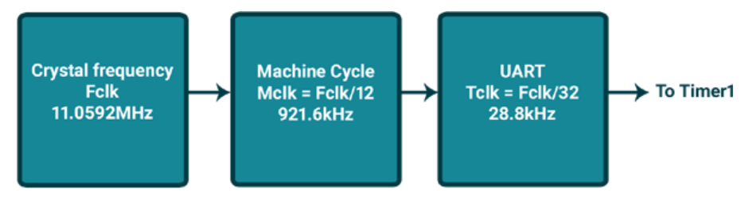

Now as soon as the RFID card is applied on RFID reader, the data is received by microcontroller serial in SBUF which later is transmitted to a safe location. 8051 UART has a serial interrupt. Whenever data is transmitted or received, serial interrupt flags TI and RI are activated respectively.

**Steps to receive data serially**

1. Configure Timer 1 in auto-reload mode.
2. Load TH1 with value as per required baud rate e.g., for 9600 baud rate load 0xFD.
3. Load SCON with serial mode and control bits. e.g., for mode 1 and enable reception, load 0x50.

4. TR1 is set to 1 to start timer 1 and RI is cleared by CLR RI instruction.

5. When RI is raised, SBUF has the byte received from the virtual terminal; its contents are

moved into a safe place.

6. To receive next character, go to step 5.

**Steps to send data serially**

1. Configure Timer 1 in auto-reload mode.
2. Load TH1 with value as per required baud rate e.g., for 9600 baud rate load 0xFD
3. Load SCON with serial mode and control bits. e.g., for mode 1 and enable reception, load 0x50.
4. Start timer1 by setting TR1 bit to 1 and TI is cleared by CLR TI instruction
5. Load transmitting data in the SBUF register.
6. Wait until loaded data is completely transmitted by polling the TI flag.

7. When the TI flag is set, clear it, and repeat from step 6 to transmit more data.

Here the TI flag bit is important to know whether or not 8051 is ready to transfer another byte. TI flag bit is raised by the 8051 after transfer of data. The TI flag is cleared by the programmer by instructions like “CLR TI”.

RI bit is also important as RI = 1 indicates the entire character byte has been received and can be read before overwritten by next data. When RI=1, content of SBUF is copied to a safe place. After the SBUF contents are copied, the RI flag bit must be cleared to 0.

After the data has been transmitted and placed into a safe place, it is being checked against the records for which attendance has to be recorded.  If there exists a record with that RFID tag, the name is displayed on the LCD screen and attendance is marked but if no such record RFID exists, it displays “NO USER FOUND”.

# Flow chart

The flow chart below shows the serial communication inside a 8051 Microcontroller.

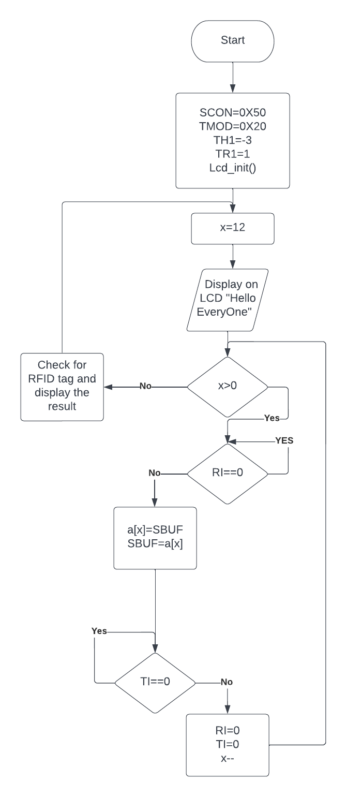

* **Circuit Simulation**

# 

# This is our simulated circuit where microcontroller 8051 used C code, whose repo link is mentioned below. Here, we have used an external header file, which we had taken from the internet, for controlling the result on LCD. This header files contains various functions to displaying, shifting and clearing the result on the LCD.

# Output Screenshots

# Picture 1 and 3 shows name

# corresponding to the RFID and

# mark their attendance.

# 

# Picture 2 shows that if

# attendance is already marked

# It shows “already marked” on

# The LCD.

# 

# 

# Picture 4 shows that if no user

# Exist with corresponding

# RFID, then it shows “No user found”.

# Code Link

# https://github.com/Shivam311201/RFID-Attendance-System

# Conclusion

In our project, we have successfully simulated the RFID based attendance system using microcontroller which is a core concept of computer architecture. We have used various core components of computer architecture like LCD, microcontroller 8051. We have built the code for functioning of 8051 microcontroller.

We had learnt in deep about the structure of microcontroller. We have understood the how the serial transfer of the data occurs within the same. This technology is helpful at various places like attendance system in schools, at metro and railway stations for ticketing system.

For future, we are planning to improve the circuit using finger print recognition so that no other person can mark the proxy of others. We have also planned to build the hardware project for the same to have a better hands-on-experience.

## DEPARTMENT OF COMPUTER ENGINEERING DELHI TECHNOLOGICAL UNIVERSITY

(Formerly Delhi College of Engineering) Bawana road, Delhi-110042

## BIBLIOGRAPHY

1. http://www.electroons.com/8051/electroons/serial_communication.html
2. The 8051 Microcontroller and Embedded Systems Using Assembly and C Second Edition Muhammad Ali Mazidi, Janice Gillispie Mazidi and Rolin D.McKinlay
3. https://www.gadgetronicx.com/serial-communication-in-8051-microcontroller/
4. https://silo.tips/download/8051-serial-port-crystal-txd-i-o-device-rxd-embedded-systems-peripherals